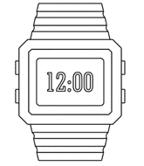

**PO3_DGW_Digital watch**

**(CYRS)**

Table 1 Status Table

|  |  |  |  |  |
| --- | --- | --- | --- | --- |
| **Document Name** | **Author** | **Version** | **Update Date** | **Status** |
| CYRS | Hammam Mazen | V1.5 | 06/02/2020 | Proposed |

**DOCUMENT HISTORY**

Table 2 Document History including Version, Description, Author, Date and Status

|  |  |  |  |  |
| --- | --- | --- | --- | --- |
| **Version** | **Description of Change** | **Author** | **Date of last update** | **Status** |
| 1.0 | - Initial creation of the document. | Mostafa Nader  Hammam Mazen | 22/1/2020 | Draft |
| 1.1 | - Updated the block diagram.  - Added two hardware requirements.  - Modified the project description. | Mostafa Nader  Hammam Mazen | 23/1/2020 | Draft |
| 1.2 | - Updated cover page by adding a logo  - Added #SW and #HW. | Mostafa Nader  Hammam Mazen | 23/1/2020 | Draft |
| 1.3 | - Req_ PO3_DGW_CYRS_03_V01 & Req_ PO3_DGW_CYRS_06_V01 are updated  - Document History table updated | Mostafa Nader  Hammam Mazen | 25/1/2020 | Proposed |
| 1.4 | - All requirements updated with system level prospective.  -Added status table  -Added Reference table | Mostafa Nader | 4/2/2020 | Proposed |
| 1.5 | - Headers of requirements section modified with modes instead of Req IDs | Hammam Mazen | 6/2/2020 | Proposed |

Contents

1 INTRODUCTION 4

1.1 Project Description 4

2 METHODOLOGY 4

3 REQUIREMENTS 5

3.1 Time display mode 5

3.2 Alarm mode 5

3.3 Stopwatch mode start 6

3.4 Stopwatch mode stop 6

3.5 Stopwatch mode reset 6

3.6 System components 6

List of Figures

Figure 1 Digital-Watch High Level Block Diagram 4

List of Tables

Table 1 Status Table 1

Table 2 Document History including Version, Description, Author, Date and Status 2

Table 3 Reference Table…………………………………………………………………………..6

# INTRODUCTION

Digital watches are common now a days, digital watches show the time as numbers, e.g., 10:55 Am instead of a shorthand pointing towards the number 10 and a long hand pointing towards the number 11. The digits are usually shown as a [seven-segment display](https://en.wikipedia.org/wiki/Seven-segment_display) or a LCD display. Sometimes this digital watches includes some extra features besides displaying the time in numbers format, e.g., lighting the display, stopwatch, alarm and more other features depending on the manufacturer.

## Project Description

This project will reference a Digital-Watch including several implemented features e.g. displaying a digital format of the current time to the user, setting alarm times that triggers a buzzer when the time hits the set time, stop watch that helps the user to count time according to his requirements and in this document “Customer Requirement Specifications (CYRS) document” the basic CRS requirements will be specified into software and hardware more detailed requirements.

# METHODOLOGY

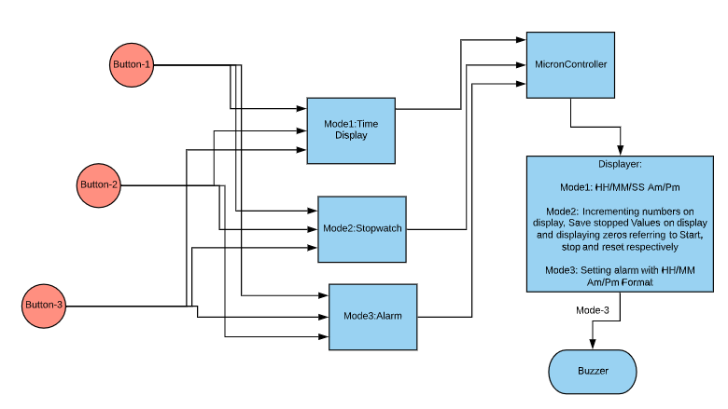

Figure 1 Digital-Watch High Level Block Diagram

# REQUIREMENTS

## Time display mode

Req_ PO3_DGW_CYRS_01_V01.2 #SW

{

The System shall display the current time in this format (HH/MM/SS Am/Pm) on a displayer if the Time-display mode is chosen

}

## Alarm mode

Req_ PO3_DGW_CYRS_02_V01.1 #SW

{

The System shall notify the user with a buzzer when the settled alarm time arrives if the alarm mode is chosen

}

## Stopwatch mode start

Req_ PO3_DGW_CYRS_03_V01.2 #SW

{

The System shall start counting time referring to real time seconds, minutes and hours if the start in the Stopwatch mode is chosen

}

## Stopwatch mode stop

Req_ PO3_DGW_CYRS_04_V01.1 #SW

{

The System shall save its last values and stops counting time for the user if the stop in the Stopwatch mode is chosen

}

## Stopwatch mode reset

Req_ PO3_DGW_CYRS_05_V01.1 #SW

{

The System shall restart its counter to zeros if the reset in the Stopwatch mode is chosen

}

## System components

Req_ PO3_DGW_CYRS_06_V01.2 #SW

{

The System shall include three buttons to be able to control between the three modes (Time-display, Stopwatch and alarm) according to the user’s choice and to control the inner features inside every mode.

}

Table 3 Reference Table

|  |  |  |
| --- | --- | --- |
| Reference Input Documents | Version | Status |
| CRS | ___ | ___ |
| SIQ | ___ | ___ |